Voice over IP

Today the internet is the dominant medium for information and data. Internet is so wide spread that users want to use the internet for telephone calls too.
First attempts where the introduction of chat channels in games and special programs for chatting like Skye. This developed to an integration of the internet telephony into the telephone world named Voice over IP.
With a voice over IP Access you get a telephone number and are reachable from every telephone in the telephone network. You also can call every telephone number in the classical telephone network.

Long term target is to have only one network for voice and data (network-convergence).
Instead of a PC you can use a dedicated VOIP-telephone that has everything inside the telephone for VOIP-conversation so you don’t need a computer for VOIP anymore.

Speech coding:
G.711 is the coding algorithm in the classical telephone network and is also the most commonly used algorithm in VOIP.
The transmission bandwidth needed for a 64kb/s voice channel with G.711 coding over IP is about 80kb/s including the overhead of the packets. There are some competing algorithms using lower data rates like ADPCM (G.726) or CELP that provides higher speech channel bandwidth (up to 7 kHz)

Data transport:

Internet is a packet switched network that is not very good prepared to make a lot of voice connections that need low data rate but low latency times.

In small IP-packets there is a lot of overhead information that has to be transferred.

VOIP records small conversation blocks of about 20 ms and transfers the recorded samples in one packet. The Standard used here is the “Real Time Transport Protocol”

To transfer the RTP packets the Internet User Datagram Protocol is used. The transfer of the speech data is done directly between the conversation partners bypassing the telephone-center that has only the purpose of establishing and releasing conversations.

Speech quality

The main drawback using the internet for voice is the delay of the recorded speech packets.
In the internet the delay of a packet is dependent on the traffic load

During high traffic situations the transport-delay may be to long for a functioning telephone conversation!

The different transport- delays in the internet generate a jitter that has to be compensated at the receiver. A FIFO is used as a Jitter –compensation. The length of the FIOFO is a compromise between delay introduced by the FIFO and the maximum transport delay differences that can be compensated by the FIFO.

To improve real time services like VOIP in the internet new methods like Qos (prioritising real time packet transport) is introduced by IPv5

Reliability / Availability

The telephone network is one of the most reliable technical systems. This is reached by a lot of redundancy in the network. Average downtime in public telephone networks is about 2 seconds per year. Internet is by far not that reliable so higher downtimes compared to the telephone network have to be accepted when using VOIP.
Despite this there are two main application fields where use of VOIP is recommended:
- VOIP in the INTRANET
If you use VOIP only in your intranet you are also owner of the network components. By using high reliable components that also support Qos you can have a very reliable internal network that is able to support your VOIP in-house.
This eliminates the need of two installations (one for data and one for telephony)
- VOIP for cheap long distance calls
Internet connections are flat rate today and the charge is totally independent from the distance. This is the reason that VOIP is often used to make long distance calls.

Signaling protocols
There exist three competing protocols to be used by VOIP:
- SKYPE is not an open standard but a computer program that allows Voice over IP communication using a Computer! Skype is widely spread but not supported by most of the telephony and network companies.
- H.323 is a set of ITU-T standards for call signalling and control, multimedia transport and control, and bandwidth control for point-to-point and multi-point conferences
- SIP (session initiation protocol) is an IETF standard for call signalling and control.
SIP is an open standard and is supported by nearly all telephone and network companies.

SIP
A lot of new telecom providers support internet telephony using the SIP-protocol
Sipgate.at, gmx.at, t-online.de ….
If you register at any telecom provider you get:
- A sip address
example: 123456@sipgate.at
- A telephone number
example: 0720 123456
- An address of a SIP Proxy
example: sipgate.at

If you install a dedicated VOIP telephone or a VOIP-Soft phone on your computer you have to configure it for your SIP-Telephony provider(s).
The telephone will register automatically at your telecom provider each time it is powered on and connected to the internet telling the SIP-Proxy the actual IP-Address.

Initiation of a Sip-Call:
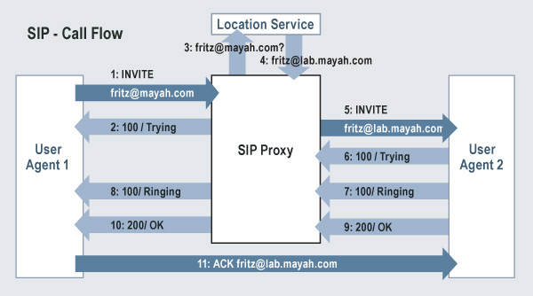
Exercise1:

Install a soft-phone for example “phoner light” on your PC. Register at a free of charge telecom provider and make free of charge calls.

Trace messages used for call management and during a call using a sniffer program (wireshark).

Answer following questions:

Which data rate is needed during a conversation?

Which messages are sent during call establishment and disconnection?

Exercise 2:

Install and configure a dedicated SIP-Telephone.

Links:

http://www.netzwelt.de/news/71004-skype-vs-sip-internet-telefone.html

